**Documentation For GitHub Practice**.

1.Created a New Repository

* Logged in.
* Created new repository by following details.
  + - * + Repository Name
        + Description
        + Public/Private
* Repository Name:usecase-archimedis.

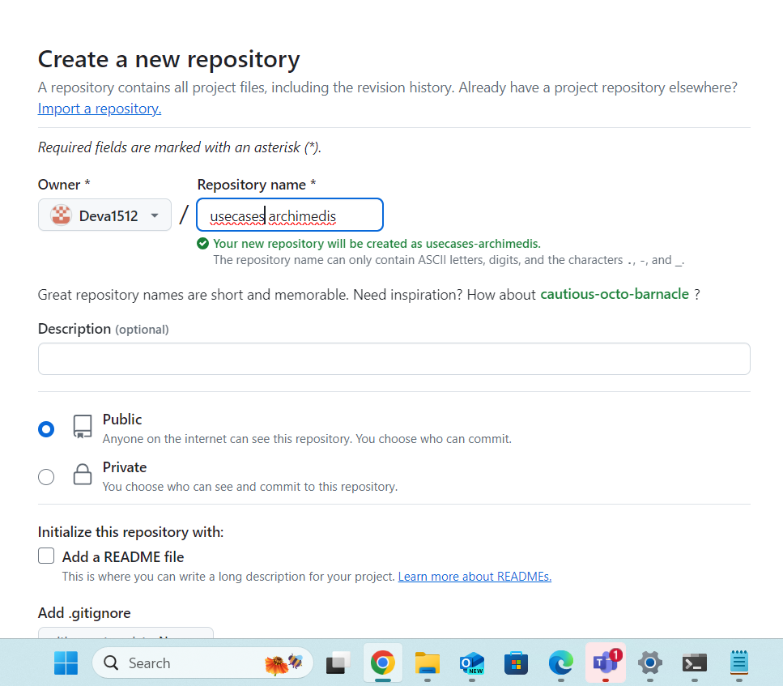

2.Clone the Repository to Our Local Machine

* Copied the repository URL.
* Opened a terminal from selected folder

Run the command- ***git clone*** [***https://github.com/Deva1512/usecase-archimedis.git***](https://github.com/Deva1512/usecase-archimedis.git)***.***

***git init***

* Navigated to repository directory- cd<repo name>.

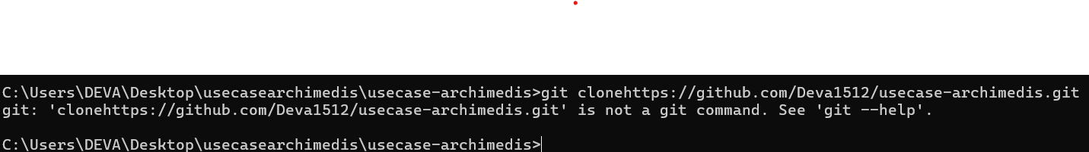

3.Adding Branches.

* Created four branches to work collaboratively.

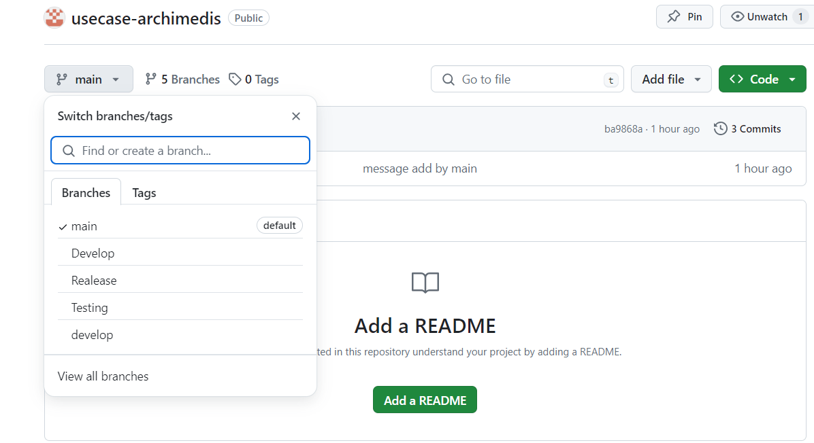

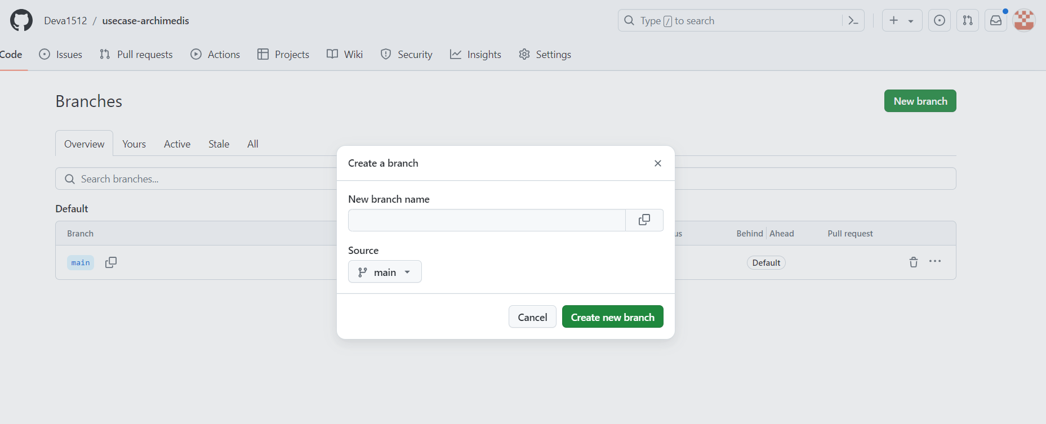

* Branches
  + - * + Develop
        + Testing
        + Release



* After creating branches add one text file in main.
* Then changed the branch to develop.

Command – ***git checkout Develop.***

* Pull the file from main branch.

Command -***git pull origin main.***

Command -***git push.***

* Now got a copy of the file.

4.Worked in Multiple Branches

* Add some messages in file from develop branch.

Command-***git checkout (any branch).***

* Added message in file

Commands

***git add .***

***git commit -m “commit msg”***

***git push***

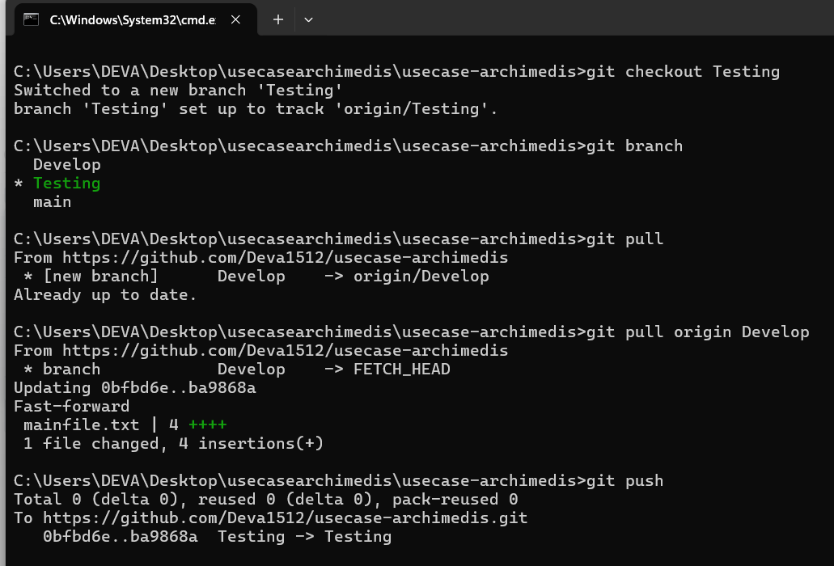

5.Branch Protection

* To protect and check the new updates in codes before merging to main branch from develop branch.
* Create ***pull request*** from develop to main branch.

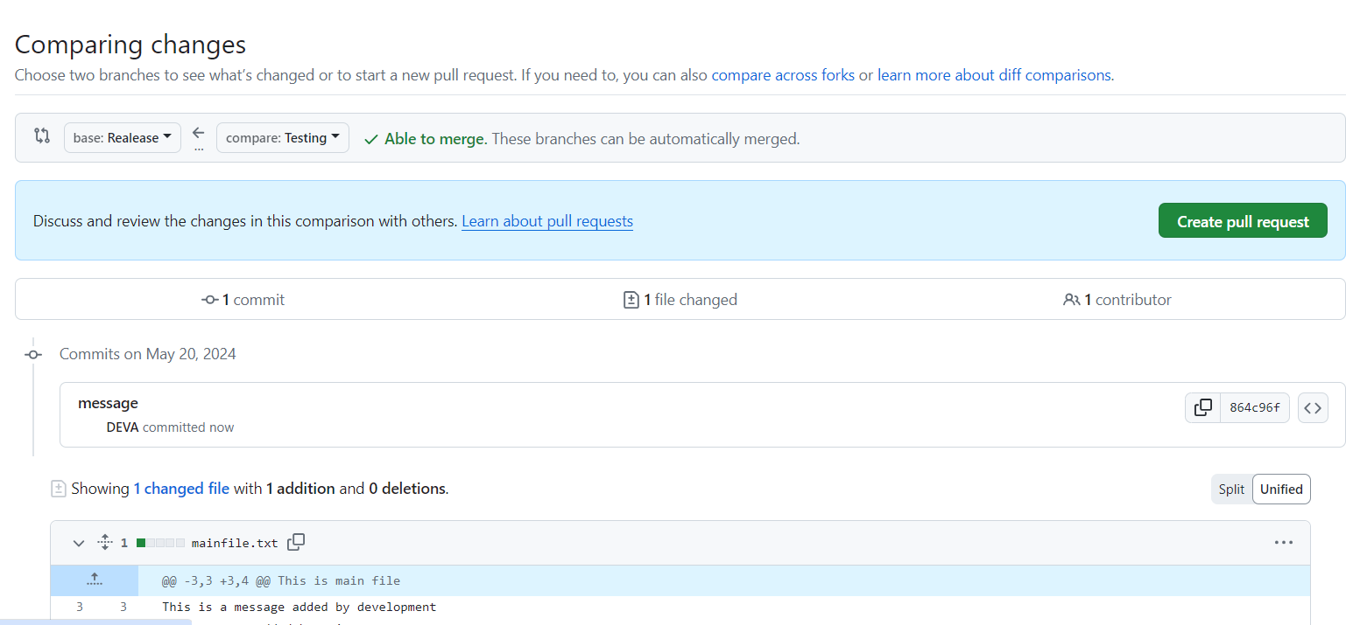

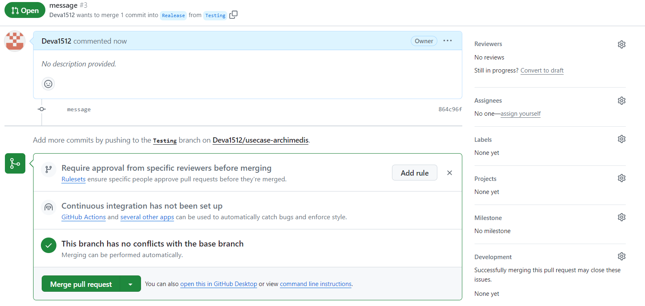

* Pull request use to assign reviewers to check updates before merging.
* After getting approve by reviews either reviewers or developer can merge the updates.